# Appendix

Table A.1. Tukey’s honest significant difference analysis on seasonal non-Dungeness crab revenue per vessel, corresponding to Figure 3b in the main text. MHW: marine heatwave period; Non-MHW: non-marine heatwave period. Bolded rows are within-behavioral-group, between-period comparisons. Of these within-group comparisons, differences with a p-value<0.05 are indicated with stars in Fig. 3b.

|  |  |  |  |  |  |
| --- | --- | --- | --- | --- | --- |
| **Group 1** | **Group 2** | **Difference** | **Lower** | **Upper** | **Adjusted p-value** |
| **MHW:Local Specialists** | **Non-MHW:Local Specialists** | 18443.58 | -25358.40 | 62245.56 | 0.91 |
| Non-MHW:Local Generalists | Non-MHW:Local Specialists | 99076.71 | 63874.12 | 134279.31 | 0.00 |
| MHW:Local Generalists | Non-MHW:Local Specialists | 271157.43 | 215093.29 | 327221.57 | 0.00 |
| Non-MHW:Roving Specialists | Non-MHW:Local Specialists | 50960.93 | 10636.99 | 91284.88 | 0.00 |
| MHW:Roving Specialists | Non-MHW:Local Specialists | 124890.20 | 75417.33 | 174363.08 | 0.00 |
| Non-MHW:Roving Generalists | Non-MHW:Local Specialists | 436511.75 | 398995.54 | 474027.96 | 0.00 |
| MHW:Roving Generalists | Non-MHW:Local Specialists | 819962.88 | 767106.93 | 872818.84 | 0.00 |
| Non-MHW:Local Generalists | MHW:Local Specialists | 80633.13 | 37124.66 | 124141.60 | 0.00 |
| MHW:Local Generalists | MHW:Local Specialists | 252713.85 | 191094.44 | 314333.26 | 0.00 |
| Non-MHW:Roving Specialists | MHW:Local Specialists | 32517.35 | -15229.74 | 80264.44 | 0.44 |
| MHW:Roving Specialists | MHW:Local Specialists | 106446.62 | 50757.04 | 162136.20 | 0.00 |
| Non-MHW:Roving Generalists | MHW:Local Specialists | 418068.17 | 372667.40 | 463468.94 | 0.00 |
| MHW:Roving Generalists | MHW:Local Specialists | 801519.30 | 742803.75 | 860234.85 | 0.00 |
| **MHW:Local Generalists** | **Non-MHW:Local Generalists** | 172080.72 | 116245.59 | 227915.85 | 0.00 |
| Non-MHW:Roving Specialists | Non-MHW:Local Generalists | -48115.78 | -88120.71 | -8110.86 | 0.01 |
| MHW:Roving Specialists | Non-MHW:Local Generalists | 25813.49 | -23399.71 | 75026.69 | 0.76 |
| Non-MHW:Roving Generalists | Non-MHW:Local Generalists | 337435.04 | 300261.93 | 374608.14 | 0.00 |
| MHW:Roving Generalists | Non-MHW:Local Generalists | 720886.17 | 668273.19 | 773499.15 | 0.00 |
| Non-MHW:Roving Specialists | MHW:Local Generalists | -220196.50 | -279394.13 | -160998.87 | 0.00 |
| MHW:Roving Specialists | MHW:Local Generalists | -146267.23 | -212038.83 | -80495.62 | 0.00 |
| Non-MHW:Roving Generalists | MHW:Local Generalists | 165354.32 | 108032.38 | 222676.26 | 0.00 |
| MHW:Roving Generalists | MHW:Local Generalists | 548805.45 | 480452.76 | 617158.14 | 0.00 |
| **MHW:Roving Specialists** | **Non-MHW:Roving Specialists** | 73929.27 | 20931.76 | 126926.79 | 0.00 |
| Non-MHW:Roving Generalists | Non-MHW:Roving Specialists | 385550.82 | 343495.65 | 427605.99 | 0.00 |
| MHW:Roving Generalists | Non-MHW:Roving Specialists | 769001.95 | 712833.25 | 825170.65 | 0.00 |
| Non-MHW:Roving Generalists | MHW:Roving Specialists | 311621.55 | 260727.71 | 362515.38 | 0.00 |
| MHW:Roving Generalists | MHW:Roving Specialists | 695072.68 | 632013.44 | 758131.92 | 0.00 |
| **MHW:Roving Generalists** | **Non-MHW:Roving Generalists** | 383451.13 | 329262.86 | 437639.40 | 0.00 |

Table A.2. Tukey’s honest significant difference analysis on seasonal home range size (in square km) per vessel, corresponding to Figure 4b in the main text. MHW: marine heatwave period; Non-MHW: non-marine heatwave period. Bolded rows are within-behavioral-group, between-period comparisons. Of these within-group comparisons, differences with a p-value<0.05 are indicated with stars in Fig. 4b.

|  |  |  |  |  |  |
| --- | --- | --- | --- | --- | --- |
| **Group 1** | **Group 2** | **Difference** | **Lower** | **Upper** | **Adjusted p-value** |
| **MHW:Local Specialists** | **Non-MHW:Local Specialists** | **43.9** | **-678.4** | **766.2** | **1.0** |
| Non-MHW:Local Generalists | Non-MHW:Local Specialists | 137.0 | -429.9 | 703.8 | 1.0 |
| MHW:Local Generalists | Non-MHW:Local Specialists | 161.0 | -791.0 | 1113.0 | 1.0 |
| Non-MHW:Roving Specialists | Non-MHW:Local Specialists | 3576.5 | 3016.9 | 4136.0 | 0.0 |
| MHW:Roving Specialists | Non-MHW:Local Specialists | 4739.1 | 4024.6 | 5453.7 | 0.0 |
| Non-MHW:Roving Generalists | Non-MHW:Local Specialists | 2608.9 | 2031.1 | 3186.7 | 0.0 |
| MHW:Roving Generalists | Non-MHW:Local Specialists | 3998.4 | 3210.2 | 4786.6 | 0.0 |
| Non-MHW:Local Generalists | MHW:Local Specialists | 93.1 | -638.1 | 824.3 | 1.0 |
| MHW:Local Generalists | MHW:Local Specialists | 117.1 | -941.1 | 1175.2 | 1.0 |
| Non-MHW:Roving Specialists | MHW:Local Specialists | 3532.6 | 2807.0 | 4258.1 | 0.0 |
| MHW:Roving Specialists | MHW:Local Specialists | 4695.2 | 3844.4 | 5546.0 | 0.0 |
| Non-MHW:Roving Generalists | MHW:Local Specialists | 2565.0 | 1825.3 | 3304.8 | 0.0 |
| MHW:Roving Generalists | MHW:Local Specialists | 3954.5 | 3041.0 | 4868.1 | 0.0 |
| **MHW:Local Generalists** | **Non-MHW:Local Generalists** | **24.0** | **-934.8** | **982.8** | **1.0** |
| Non-MHW:Roving Specialists | Non-MHW:Local Generalists | 3439.5 | 2868.5 | 4010.5 | 0.0 |
| MHW:Roving Specialists | Non-MHW:Local Generalists | 4602.2 | 3878.6 | 5325.7 | 0.0 |
| Non-MHW:Roving Generalists | Non-MHW:Local Generalists | 2472.0 | 1883.1 | 3060.9 | 0.0 |
| MHW:Roving Generalists | Non-MHW:Local Generalists | 3861.4 | 3065.1 | 4657.8 | 0.0 |
| Non-MHW:Roving Specialists | MHW:Local Generalists | 3415.5 | 2461.0 | 4370.0 | 0.0 |
| MHW:Roving Specialists | MHW:Local Generalists | 4578.1 | 3525.3 | 5631.0 | 0.0 |
| Non-MHW:Roving Generalists | MHW:Local Generalists | 2448.0 | 1482.7 | 3413.3 | 0.0 |
| MHW:Roving Generalists | MHW:Local Generalists | 3837.4 | 2733.3 | 4941.6 | 0.0 |
| **MHW:Roving Specialists** | **Non-MHW:Roving Specialists** | **1162.6** | **444.8** | **1880.5** | **0.0** |
| Non-MHW:Roving Generalists | Non-MHW:Roving Specialists | -967.5 | -1549.4 | -385.7 | 0.0 |
| MHW:Roving Generalists | Non-MHW:Roving Specialists | 421.9 | -369.2 | 1213.1 | 0.7 |
| Non-MHW:Roving Generalists | MHW:Roving Specialists | -2130.2 | -2862.3 | -1398.0 | 0.0 |
| MHW:Roving Generalists | MHW:Roving Specialists | -740.7 | -1648.1 | 166.7 | 0.2 |
| **MHW:Roving Generalists** | **Non-MHW:Roving Generalists** | **1389.5** | **585.3** | **2193.7** | **0.0** |

Table A.3. Tukey’s honest significant difference analysis on seasonal profit per vessel, corresponding to Figure 5b in the main text. MHW: marine heatwave period; Non-MHW: non-marine heatwave period. Bolded rows are within-behavioral-group, between-period comparisons. Of these within-group comparisons, differences with a p-value<0.05 are indicated with stars in Fig. 5b.

|  |  |  |  |  |  |
| --- | --- | --- | --- | --- | --- |
| **Group 1** | **Group 2** | **Difference** | **Lower** | **Upper** | **Adjusted p-value** |
| **MHW:Local Specialists** | **Non-MHW:Local Specialists** | **9107.0** | **-9384.8** | **27598.8** | **0.8** |
| Non-MHW:Local Generalists | Non-MHW:Local Specialists | -16791.5 | -32499.1 | -1083.8 | 0.0 |
| MHW:Local Generalists | Non-MHW:Local Specialists | 5184.9 | -18367.7 | 28737.5 | 1.0 |
| Non-MHW:Roving Specialists | Non-MHW:Local Specialists | 76699.6 | 59361.7 | 94037.5 | 0.0 |
| MHW:Roving Specialists | Non-MHW:Local Specialists | 100511.1 | 79681.9 | 121340.3 | 0.0 |
| Non-MHW:Roving Generalists | Non-MHW:Local Specialists | 75771.9 | 59332.7 | 92211.1 | 0.0 |
| MHW:Roving Generalists | Non-MHW:Local Specialists | 117442.9 | 95216.6 | 139669.2 | 0.0 |
| Non-MHW:Local Generalists | MHW:Local Specialists | -25898.5 | -44653.5 | -7143.5 | 0.0 |
| MHW:Local Generalists | MHW:Local Specialists | -3922.1 | -29607.6 | 21763.4 | 1.0 |
| Non-MHW:Roving Specialists | MHW:Local Specialists | 67592.6 | 47452.6 | 87732.7 | 0.0 |
| MHW:Roving Specialists | MHW:Local Specialists | 91404.1 | 68190.4 | 114617.8 | 0.0 |
| Non-MHW:Roving Generalists | MHW:Local Specialists | 66664.9 | 47293.1 | 86036.6 | 0.0 |
| MHW:Roving Generalists | MHW:Local Specialists | 108335.9 | 83860.9 | 132810.9 | 0.0 |
| **MHW:Local Generalists** | **Non-MHW:Local Generalists** | **21976.4** | **-1783.4** | **45736.2** | **0.1** |
| Non-MHW:Roving Specialists | Non-MHW:Local Generalists | 93491.1 | 75872.8 | 111109.4 | 0.0 |
| MHW:Roving Specialists | Non-MHW:Local Generalists | 117302.6 | 96239.4 | 138365.8 | 0.0 |
| Non-MHW:Roving Generalists | Non-MHW:Local Generalists | 92563.4 | 75828.7 | 109298.0 | 0.0 |
| MHW:Roving Generalists | Non-MHW:Local Generalists | 134234.4 | 111788.6 | 156680.1 | 0.0 |
| Non-MHW:Roving Specialists | MHW:Local Generalists | 71514.7 | 46647.1 | 96382.3 | 0.0 |
| MHW:Roving Specialists | MHW:Local Generalists | 95326.2 | 67909.9 | 122742.5 | 0.0 |
| Non-MHW:Roving Generalists | MHW:Local Generalists | 70587.0 | 46337.4 | 94836.6 | 0.0 |
| MHW:Roving Generalists | MHW:Local Generalists | 112258.0 | 83765.8 | 140750.1 | 0.0 |
| **MHW:Roving Specialists** | **Non-MHW:Roving Specialists** | **23811.5** | **1506.1** | **46116.9** | **0.0** |
| Non-MHW:Roving Generalists | Non-MHW:Roving Specialists | -927.7 | -19201.2 | 17345.8 | 1.0 |
| MHW:Roving Generalists | Non-MHW:Roving Specialists | 40743.3 | 17128.0 | 64358.6 | 0.0 |
| Non-MHW:Roving Generalists | MHW:Roving Specialists | -24739.2 | -46353.4 | -3125.0 | 0.0 |
| MHW:Roving Generalists | MHW:Roving Specialists | 16931.8 | -9353.9 | 43217.4 | 0.5 |
| **MHW:Roving Generalists** | **Non-MHW:Roving Generalists** | **41671.0** | **18707.4** | **64634.6** | **0.0** |

## 

## **Appendix Figures**

Figure A.1. Distribution of behavioral variables by behavioral groups (LG: Local Generalists; LS: Local Specialists; RG: Roving Generalists; RS: Roving Specialists). Letters represent significant group differences based on Tukey’s HSD.

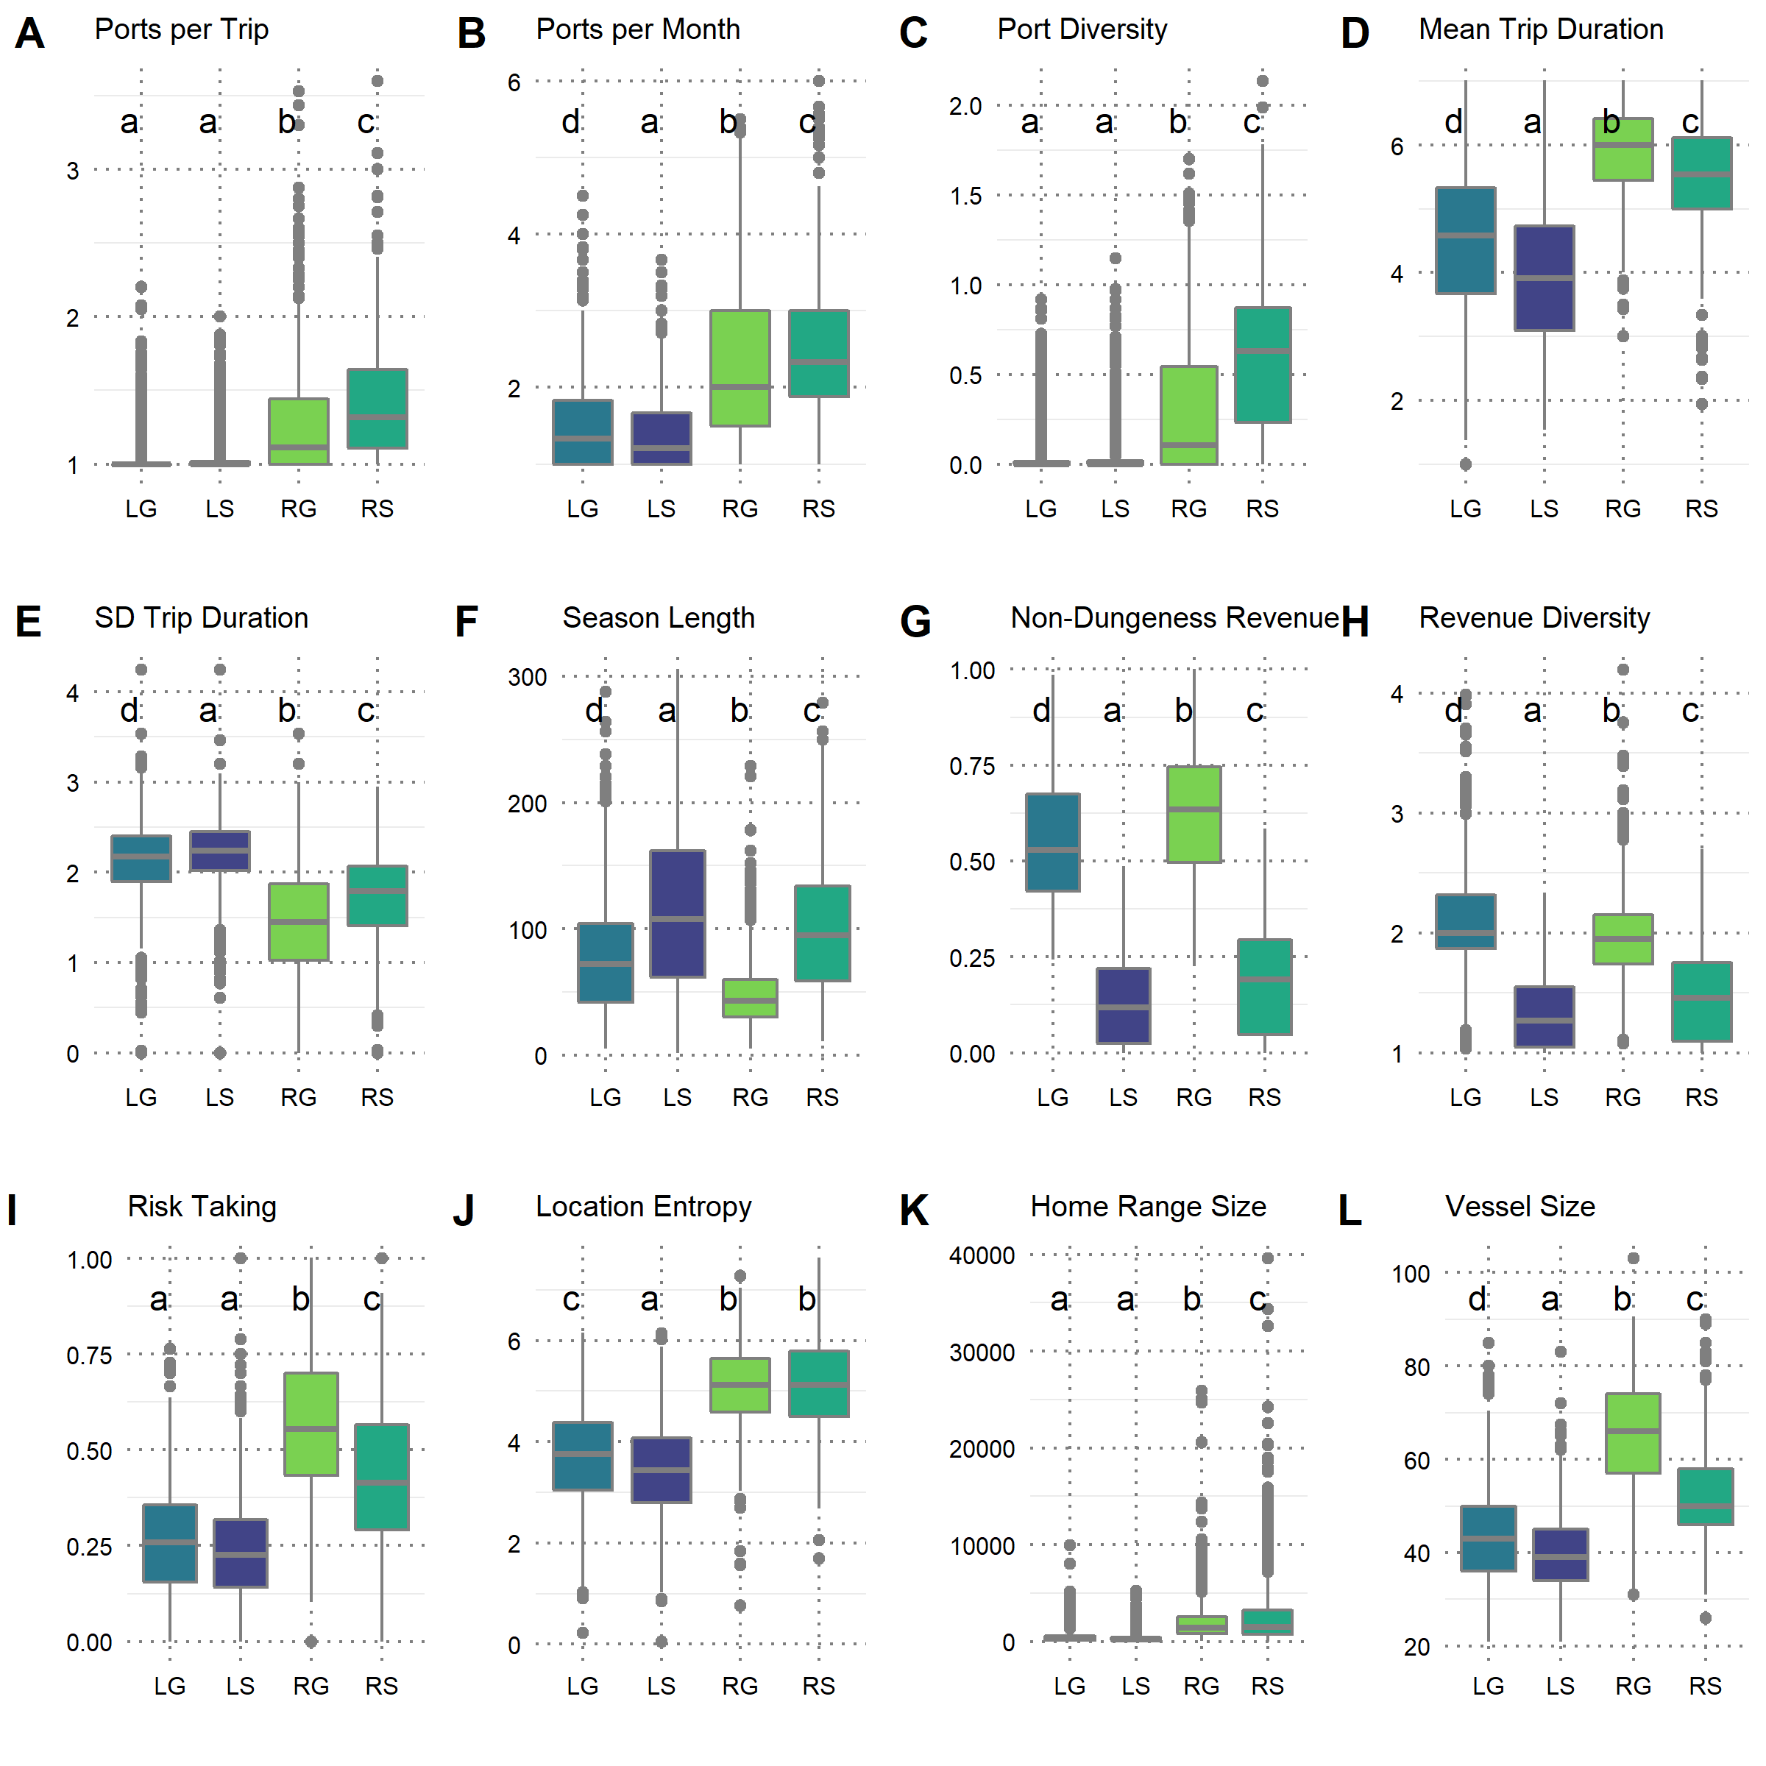

Figure A.2. Rankings of each behavioral group relative to each variable included in the cluster analysis. Groups with non-significant differences (according to Tukey’s HSD, Supplementary Figure 1) are assigned the same rank.

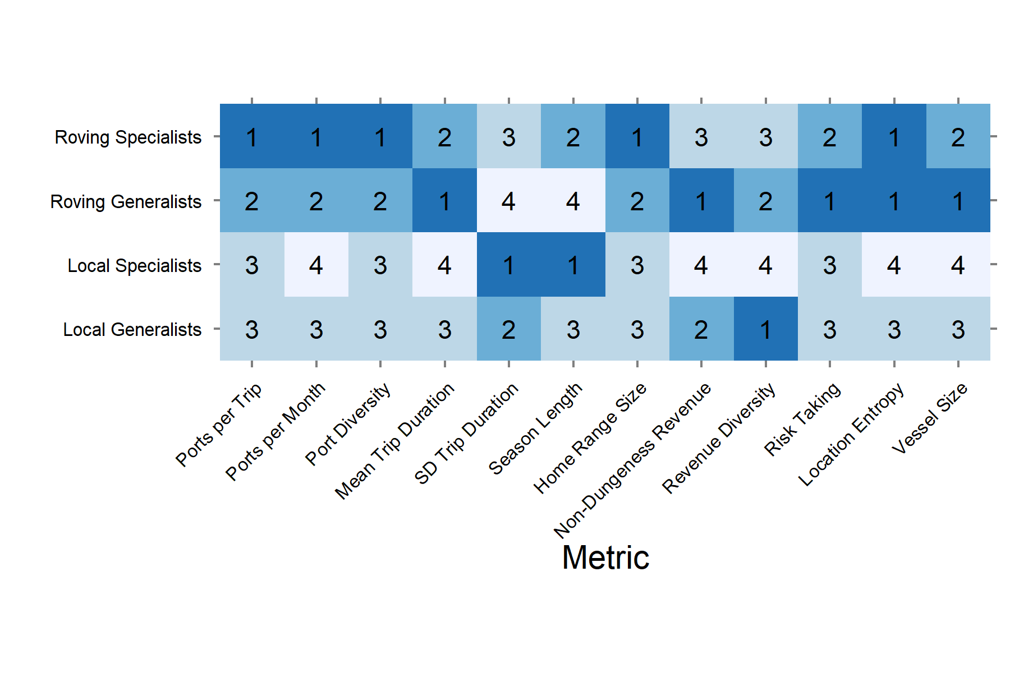

Figure A.3. Number of vessels in each clustered behavioral group across crab seasons. (a) Number of vessels in each behavioral group in each crab season. Vertical lines delineate the period of the marine heatwave. (b) Mean number of vessels (+/- 1 SD) in each group in heatwave (MHW) versus non-MHW seasons.

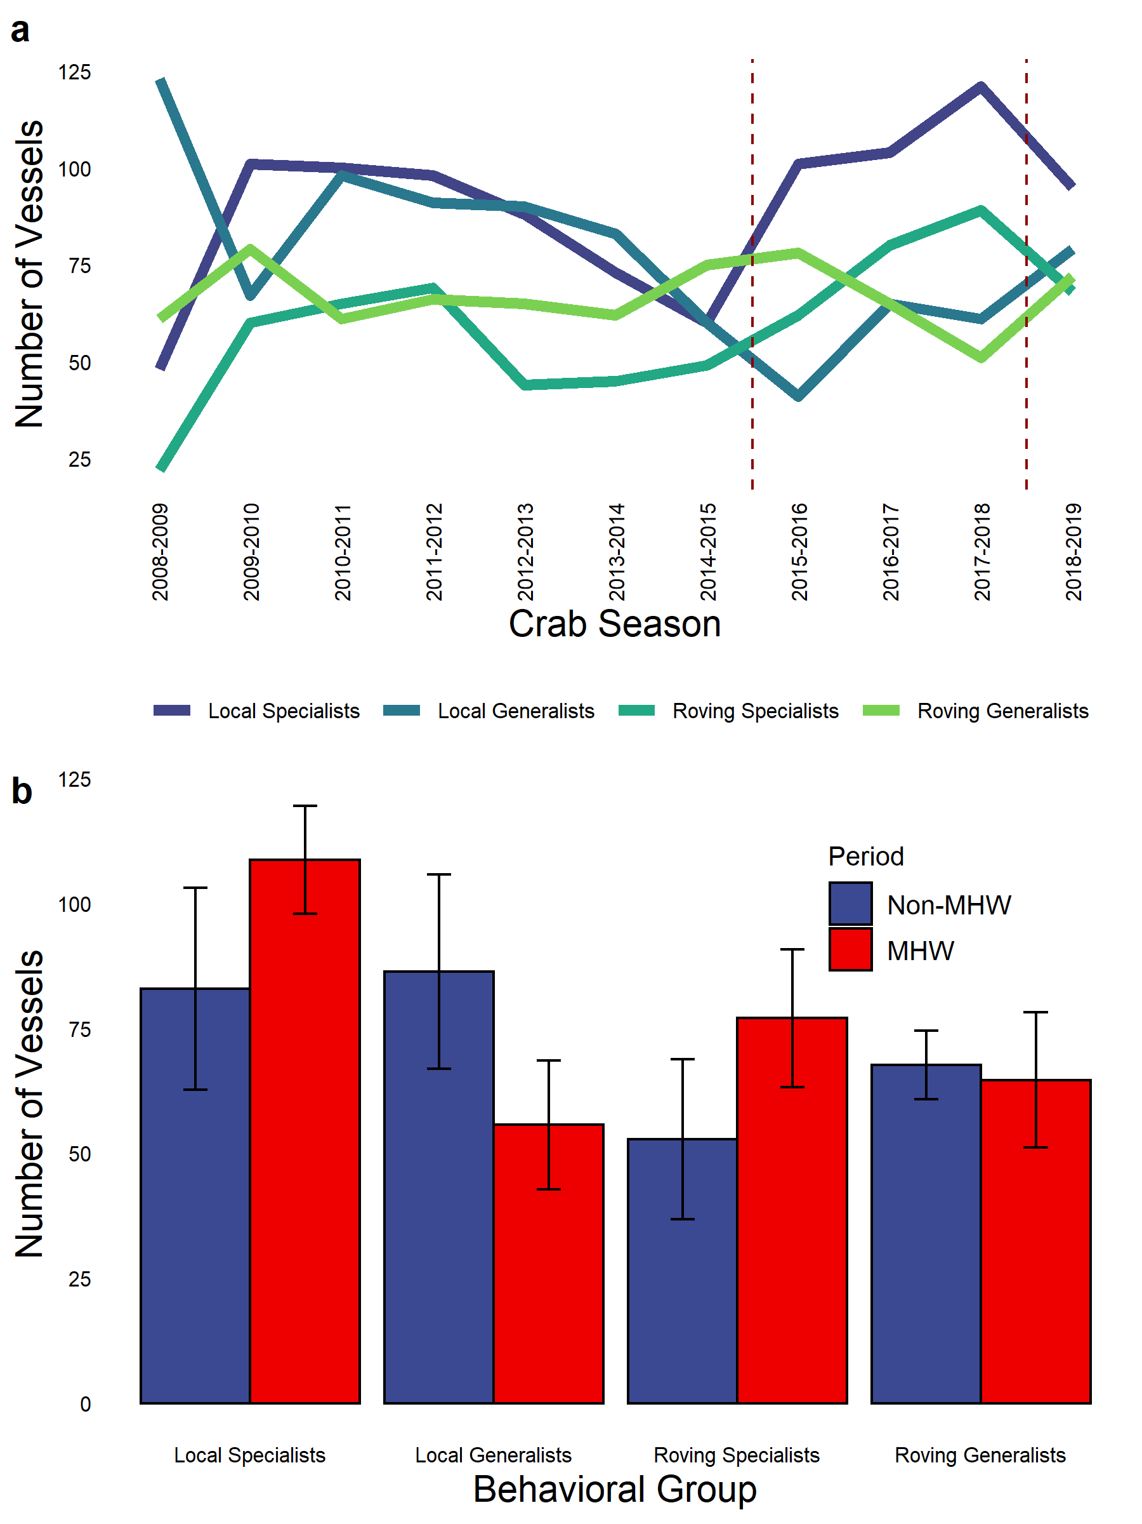

Figure A.4. Mean profit per day fished for each behavioral group in each week of the crab season, averaged across all seasons. Lines show a loess smooth across weeks for each group.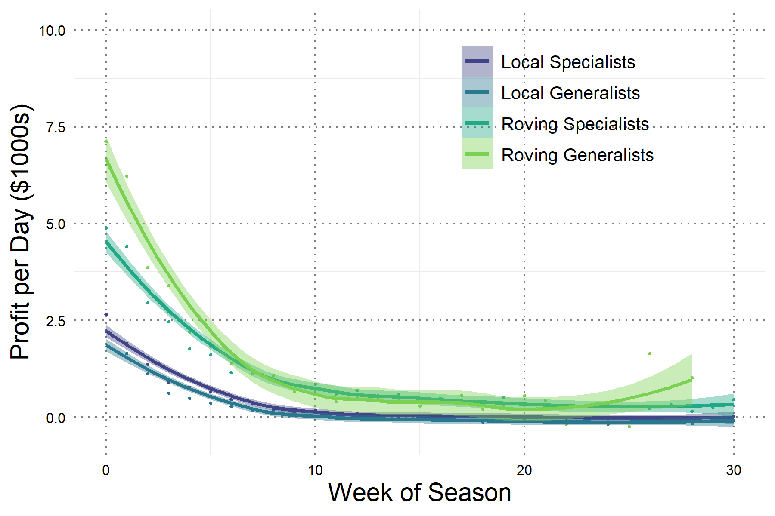

Figure A.5. Smoothed kernel density distributions of vessel length by behavioral group and crab season. We used vessel registration data from PacFIN to obtain vessel lengths in feet. Vessel lengths were checked for reporting errors, and only the most recent length value was used if a vessel reported multiple different lengths.

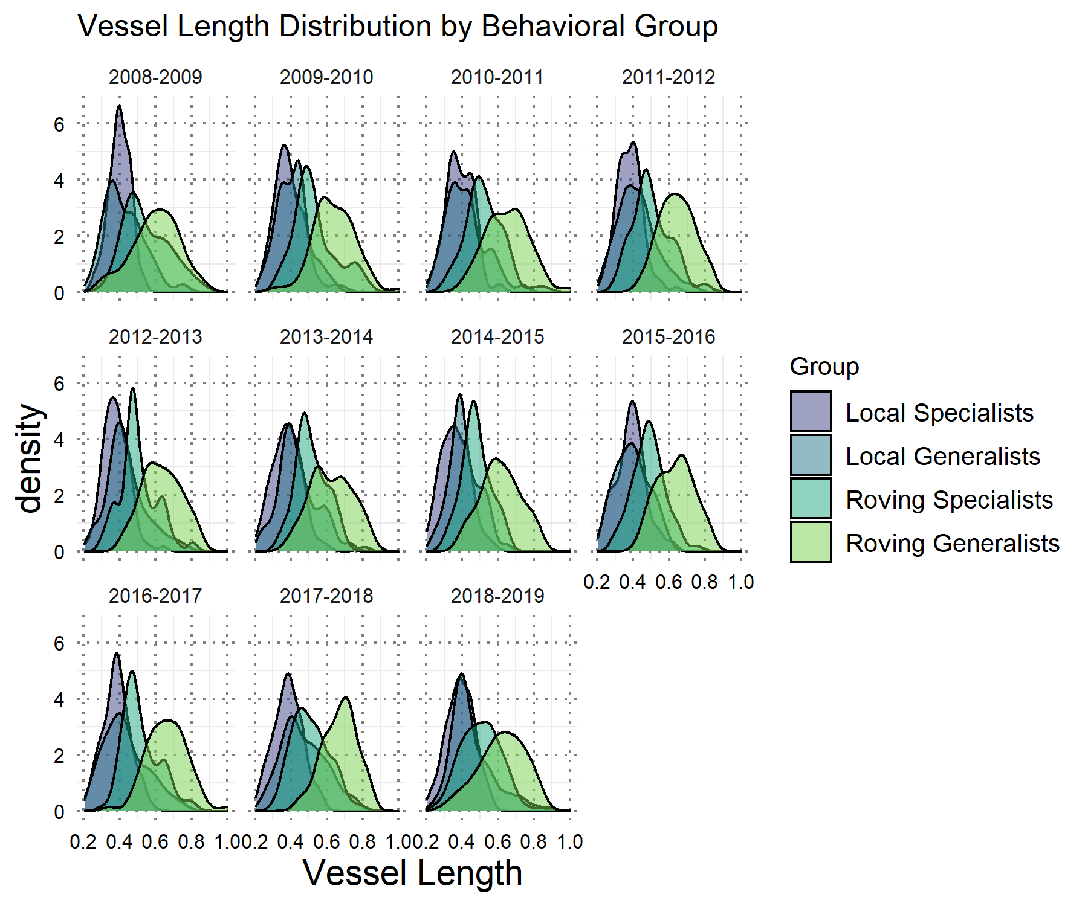

Figure A.6. Correlation of vessel length with behavioral metrics used in the cluster analysis. We used vessel registration data from PacFIN to obtain vessel lengths in feet. Vessel lengths were checked for reporting errors, and only the most recent length value was used if a vessel reported multiple different lengths.

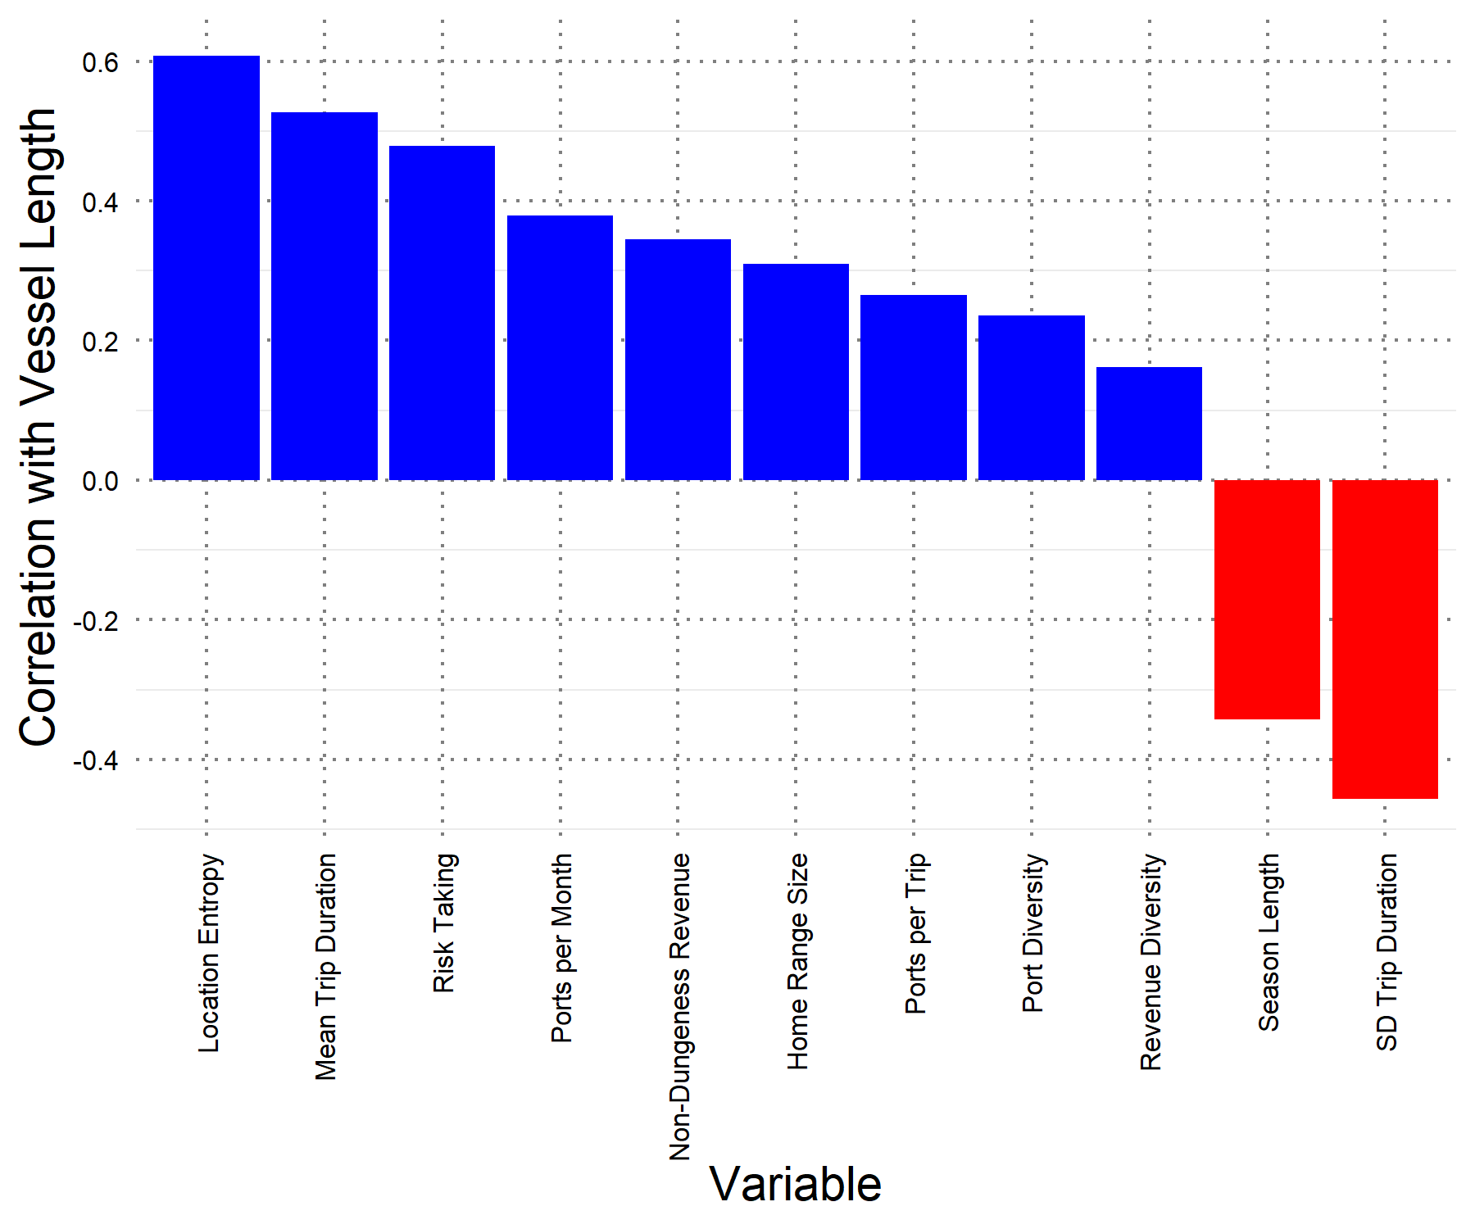

Figure A.7 Seasonal mean Dungeness crab revenue (+/- 2SE) for vessels in each behavioral group.

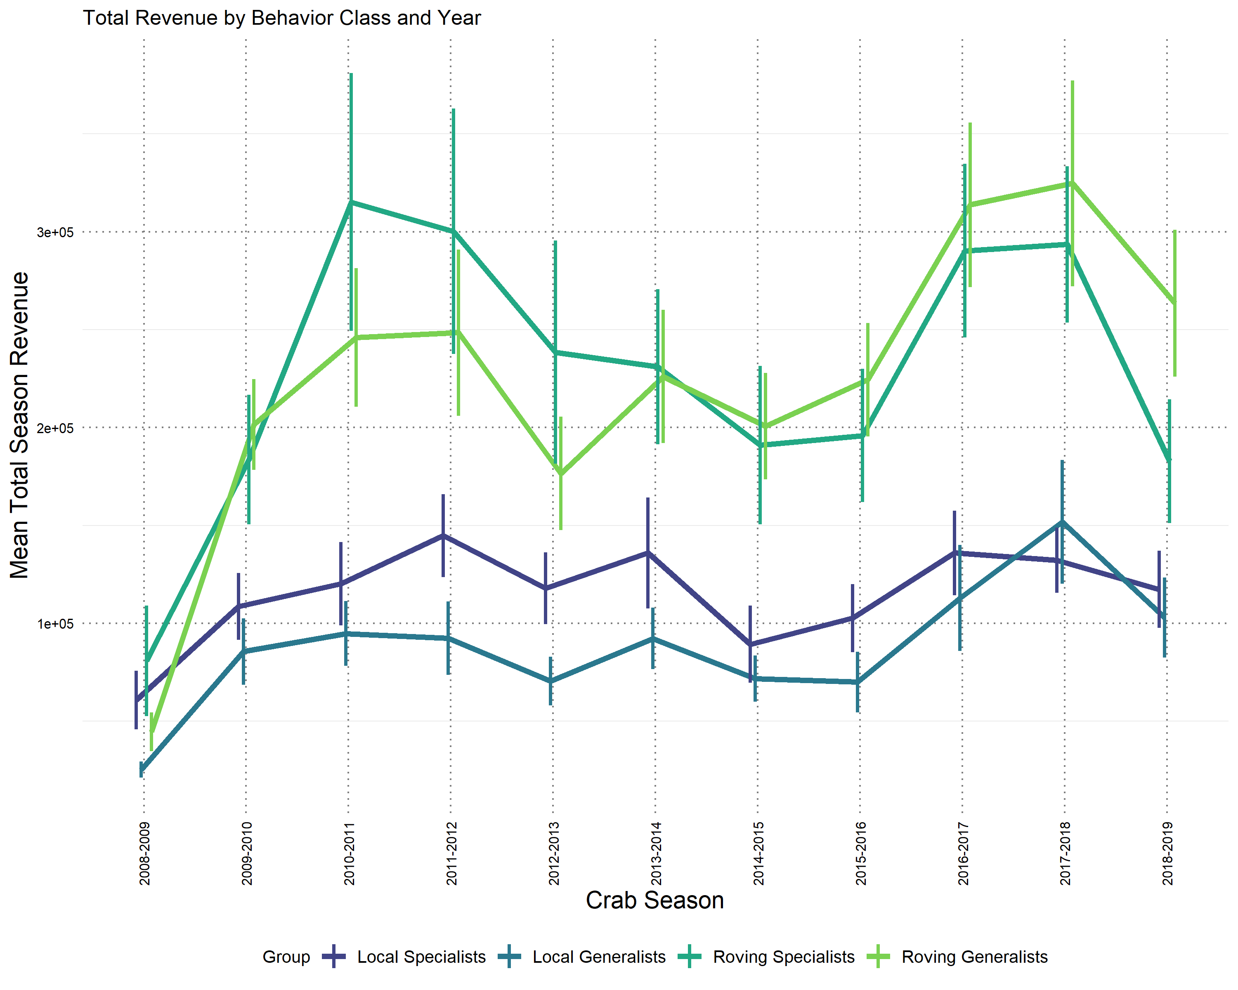

Figure A.8 Seasonal total estimated costs (main text equations 2-7) (+/- 2SE) for vessels in each behavioral group.

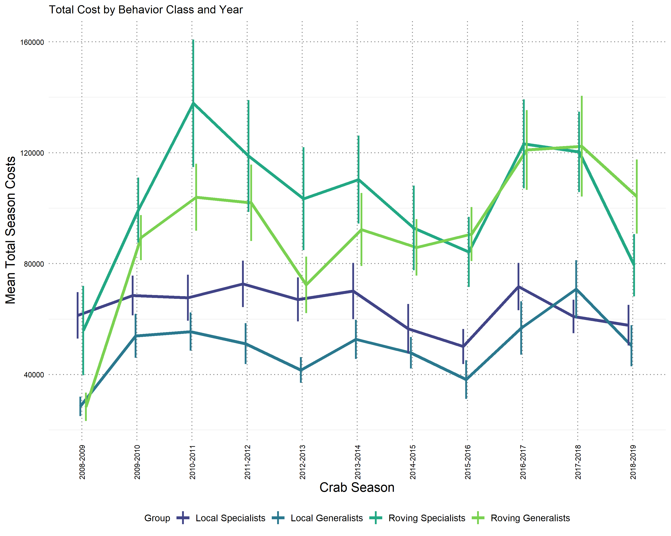

Figure A.9 Percent of fleet-wide Dungeness crab vessels represented by VMS.

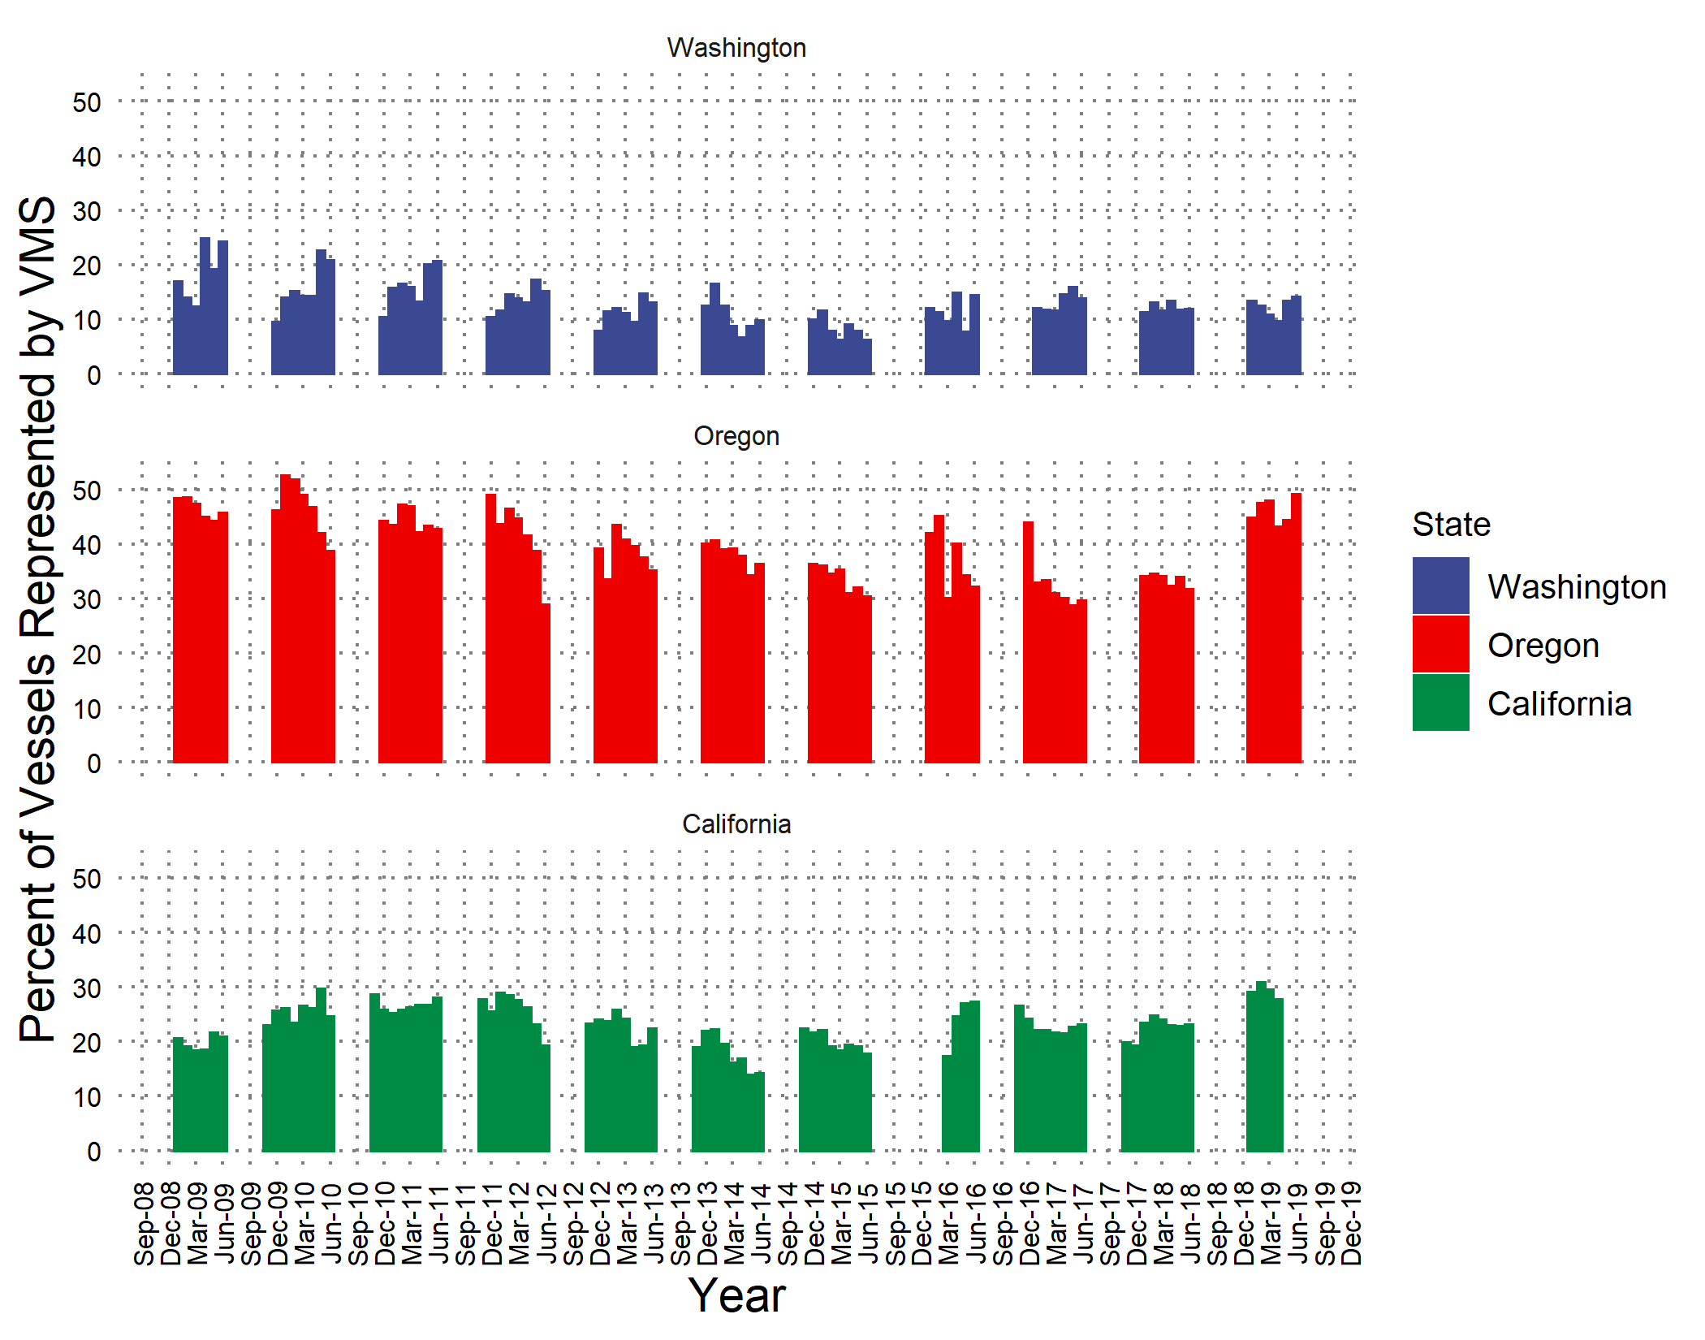

Figure A.10 Percent of fleet-wide Dungeness crab revenue represented by VMS-tracked vessels.

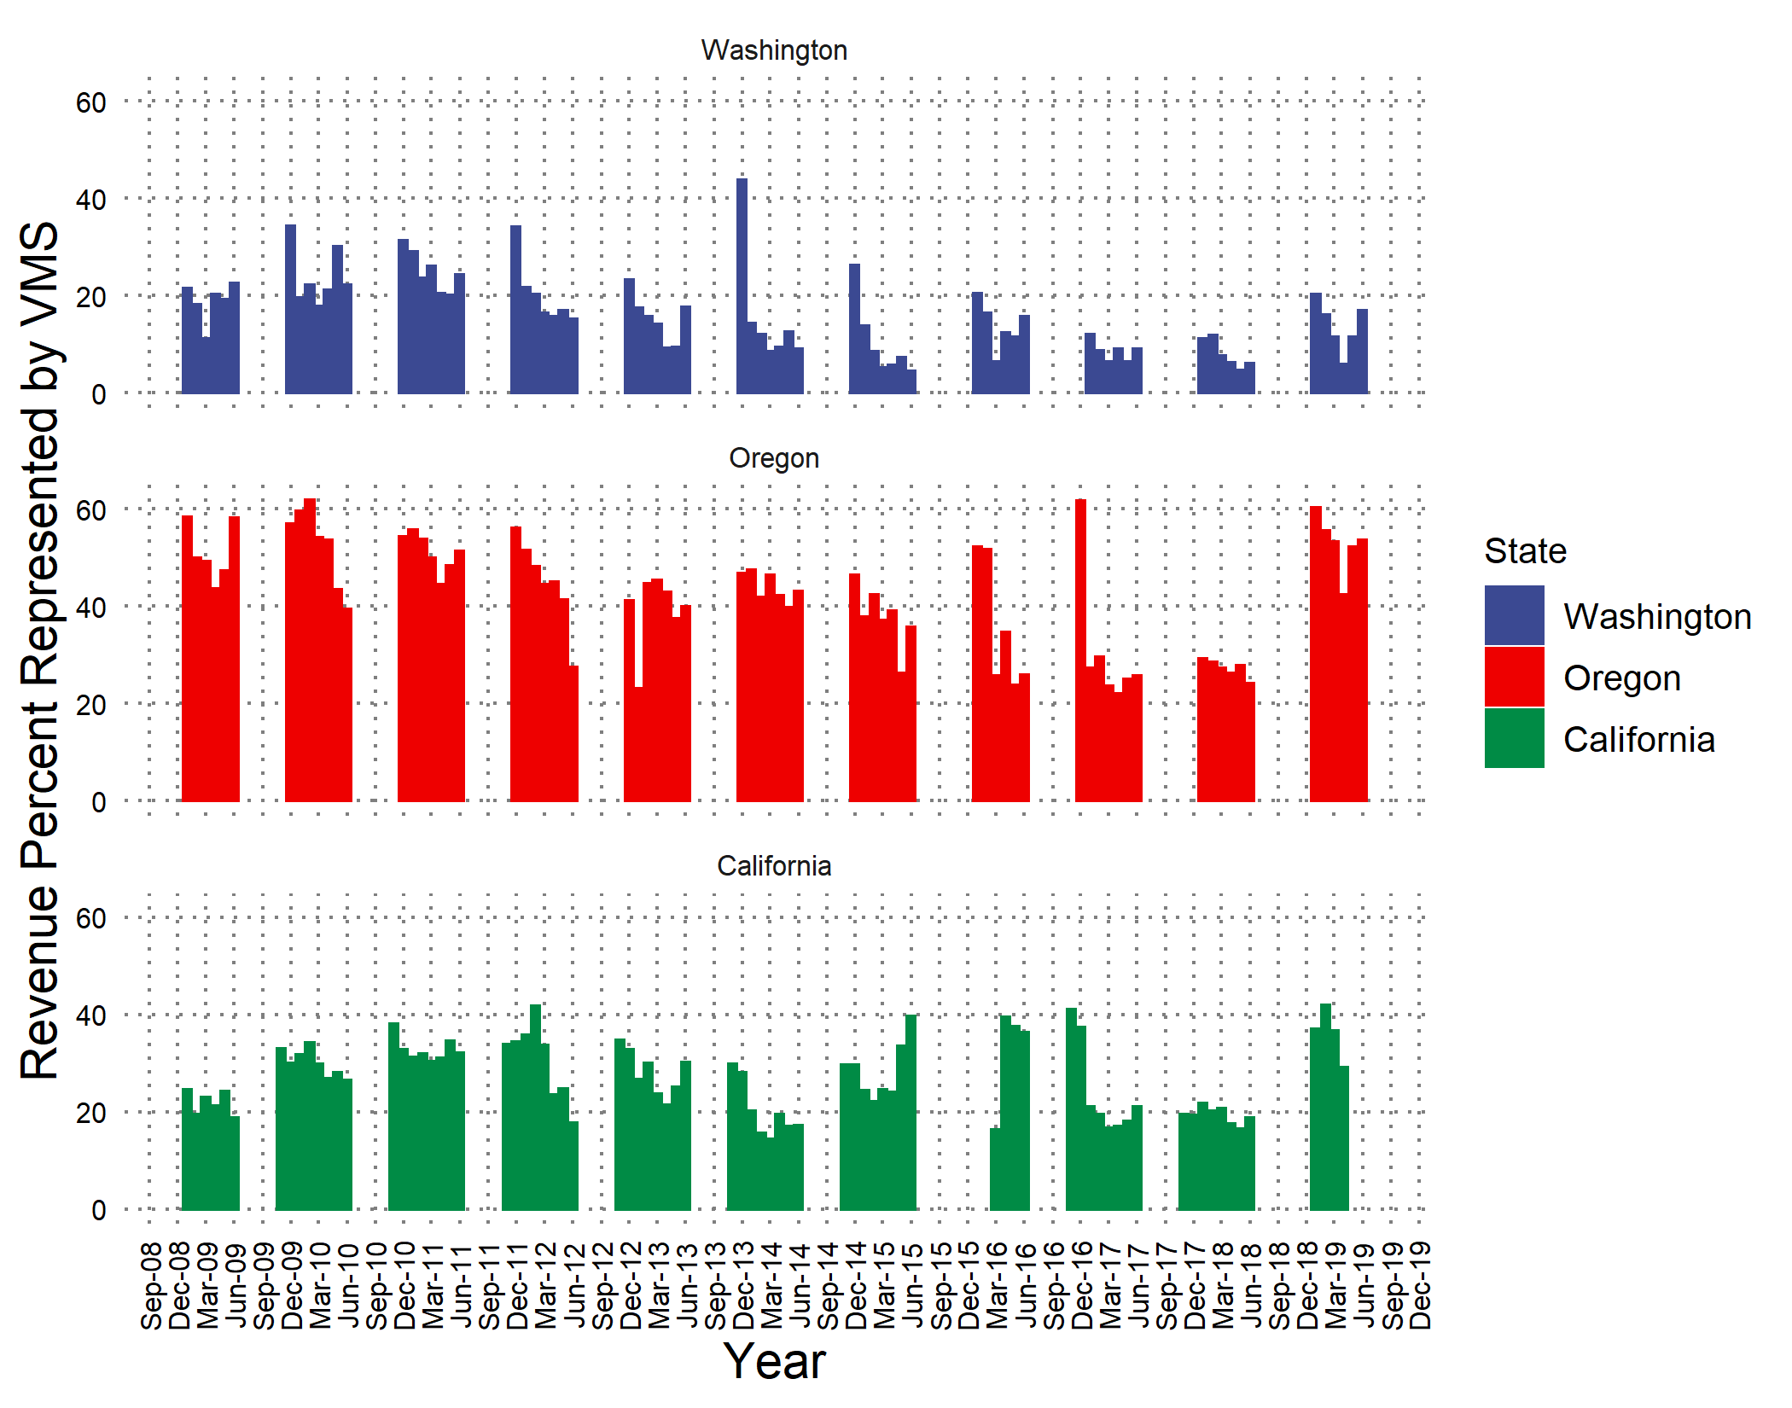

Figure A.11. (a) Mean duration in days of Dungeness crab trips across all recorded trips. (b) Proportion of trips with a duration of less than 7 days (our cutoff for maximum length of a crab trip).

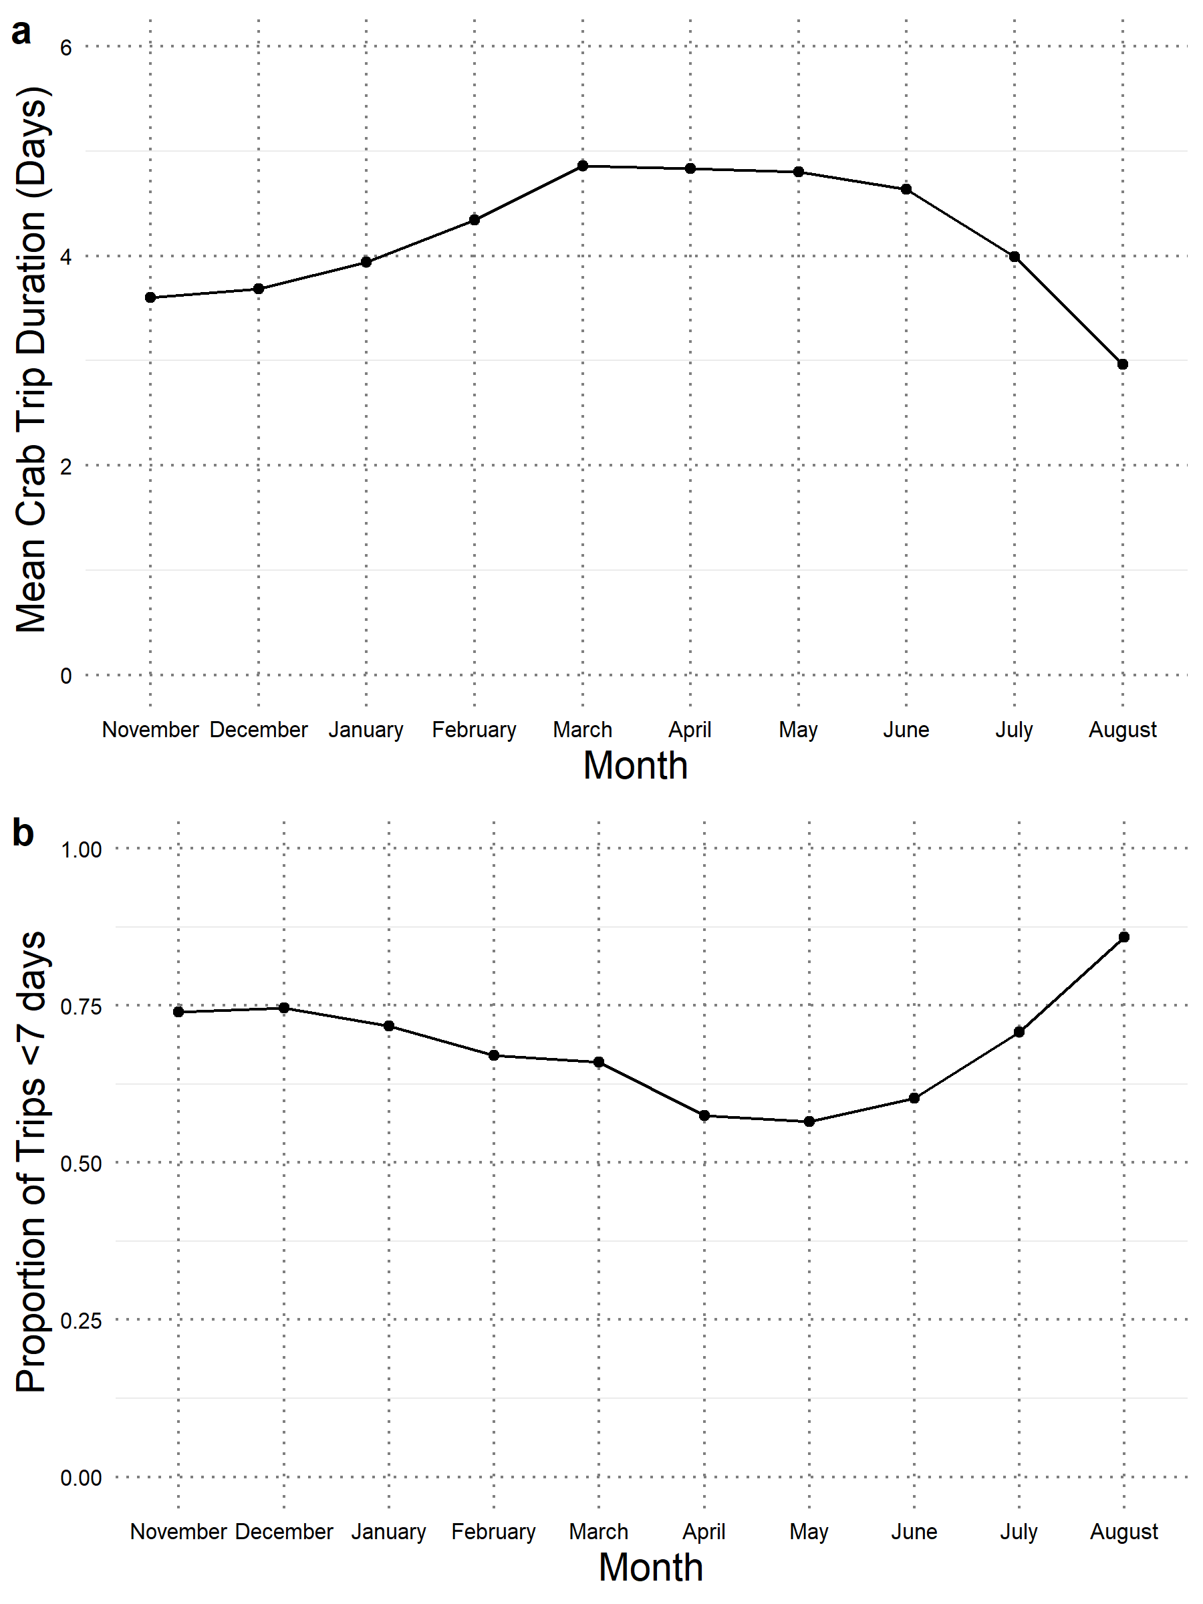

Figure A.12. Flows of individual vessels between behavioral groups over time. Total bar height indicates the total number of vessels recorded in the study in each crab season, while line thickness indicates the number of vessels staying within or moving between groups between seasons.

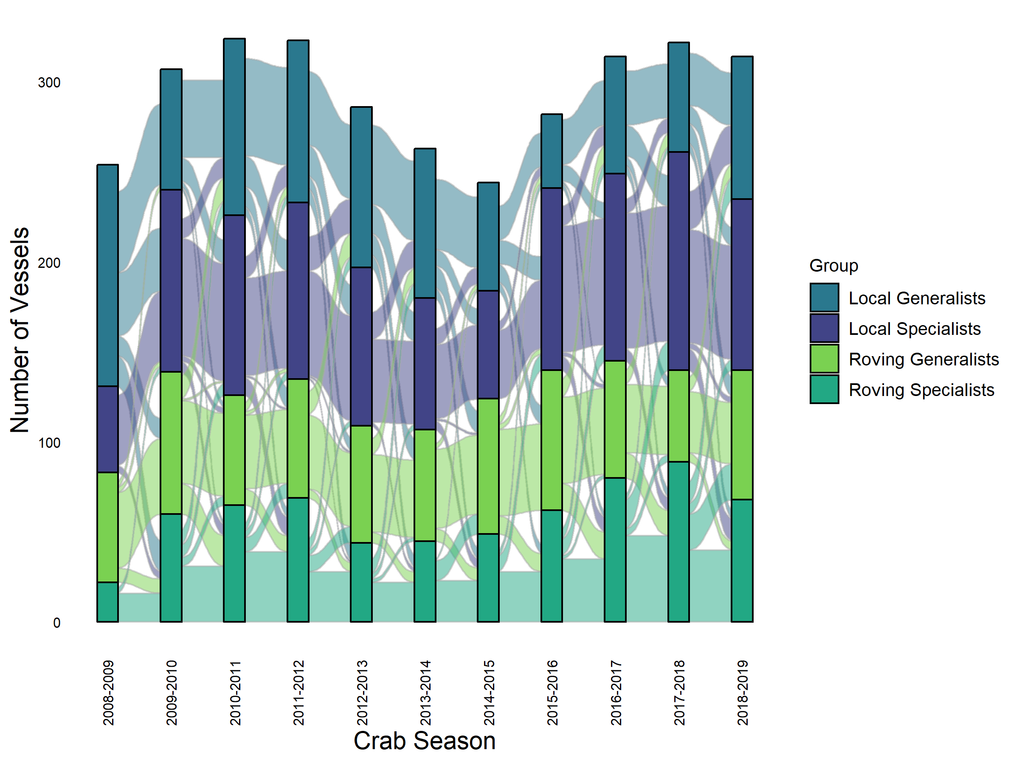

Figure A.13. Number of vessels in the sample making transitions between fisheries, and between fishing and not fishing, across the crab seasons of the study. All vessels represented were included in our Dungeness crab sample in at least one season.

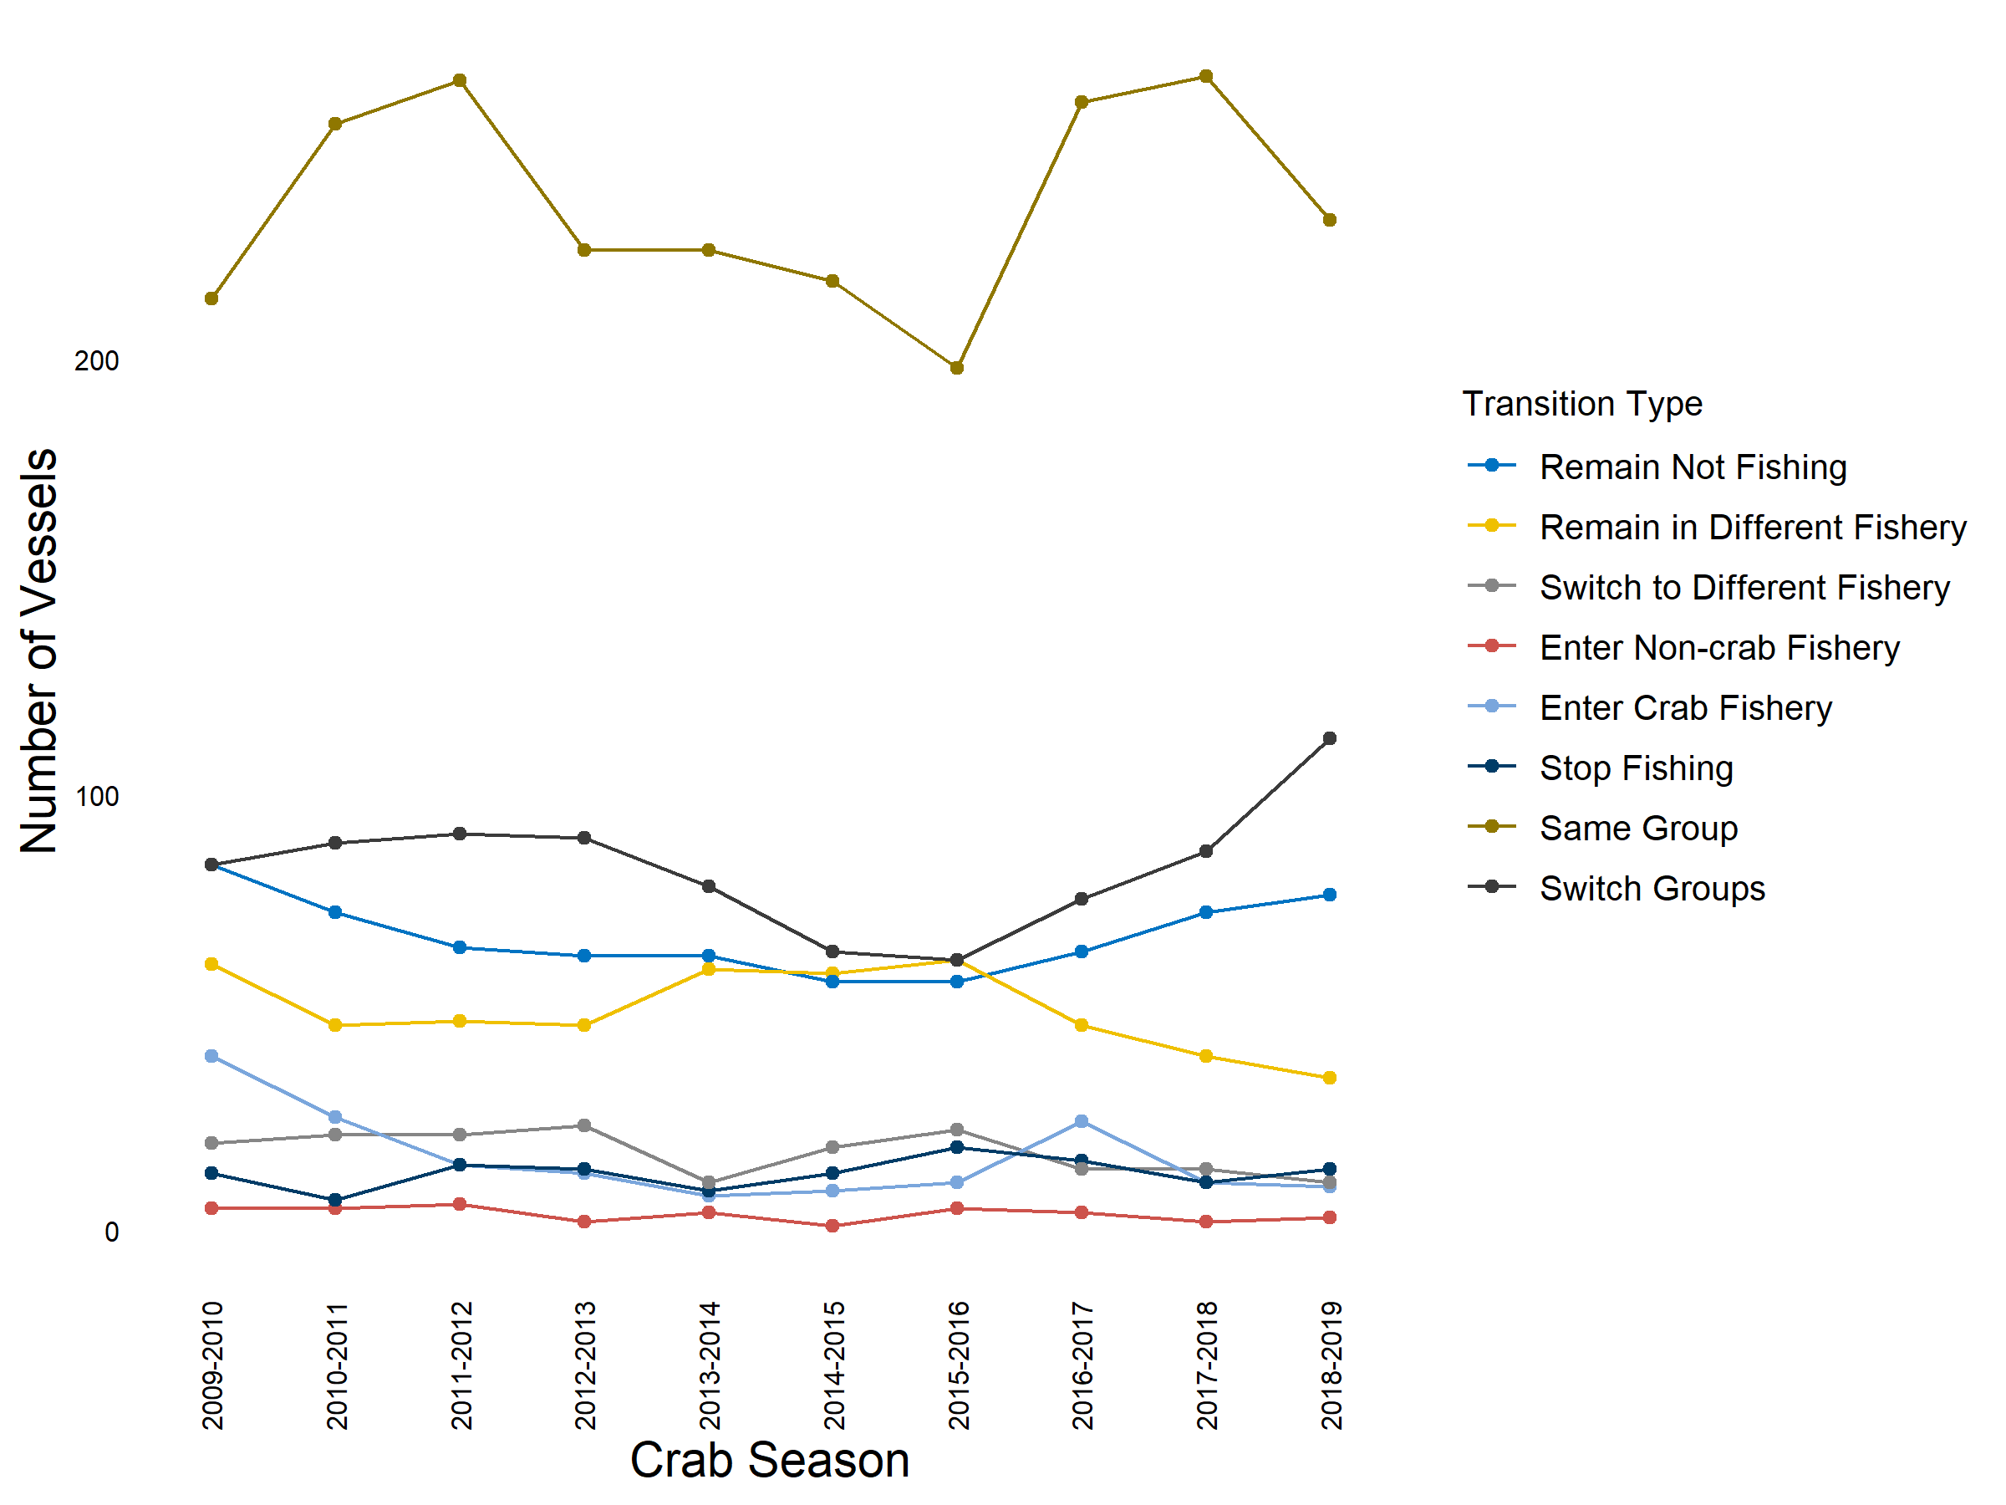

Figure A.14. Grouping of species for calculation of revenue diversity. (a) Across all Dungeness crab vessel-seasons in the analysis, percent of revenue derived from individual species landings. (b) Percent of revenue derived from species groups, based on management groupings defined by the Pacific Fisheries Management Council (<https://pacfin.psmfc.org/pacfin_pub/codes.php>) (CRAB: Dungeness crab; GRND: Groundfish species; HMSP: highly migratory species, in this case mostly albacore tuna; SRMP: shrimp species; SAMN: salmon species; OTHR: species not captured in other groups; CPEL: coastal pelagic species like sardine and anchovy; SHLL: bivalves and gastropods). Groupings in (b) were used in the derivation of the revenue diversity behavioral metric (see Methods).

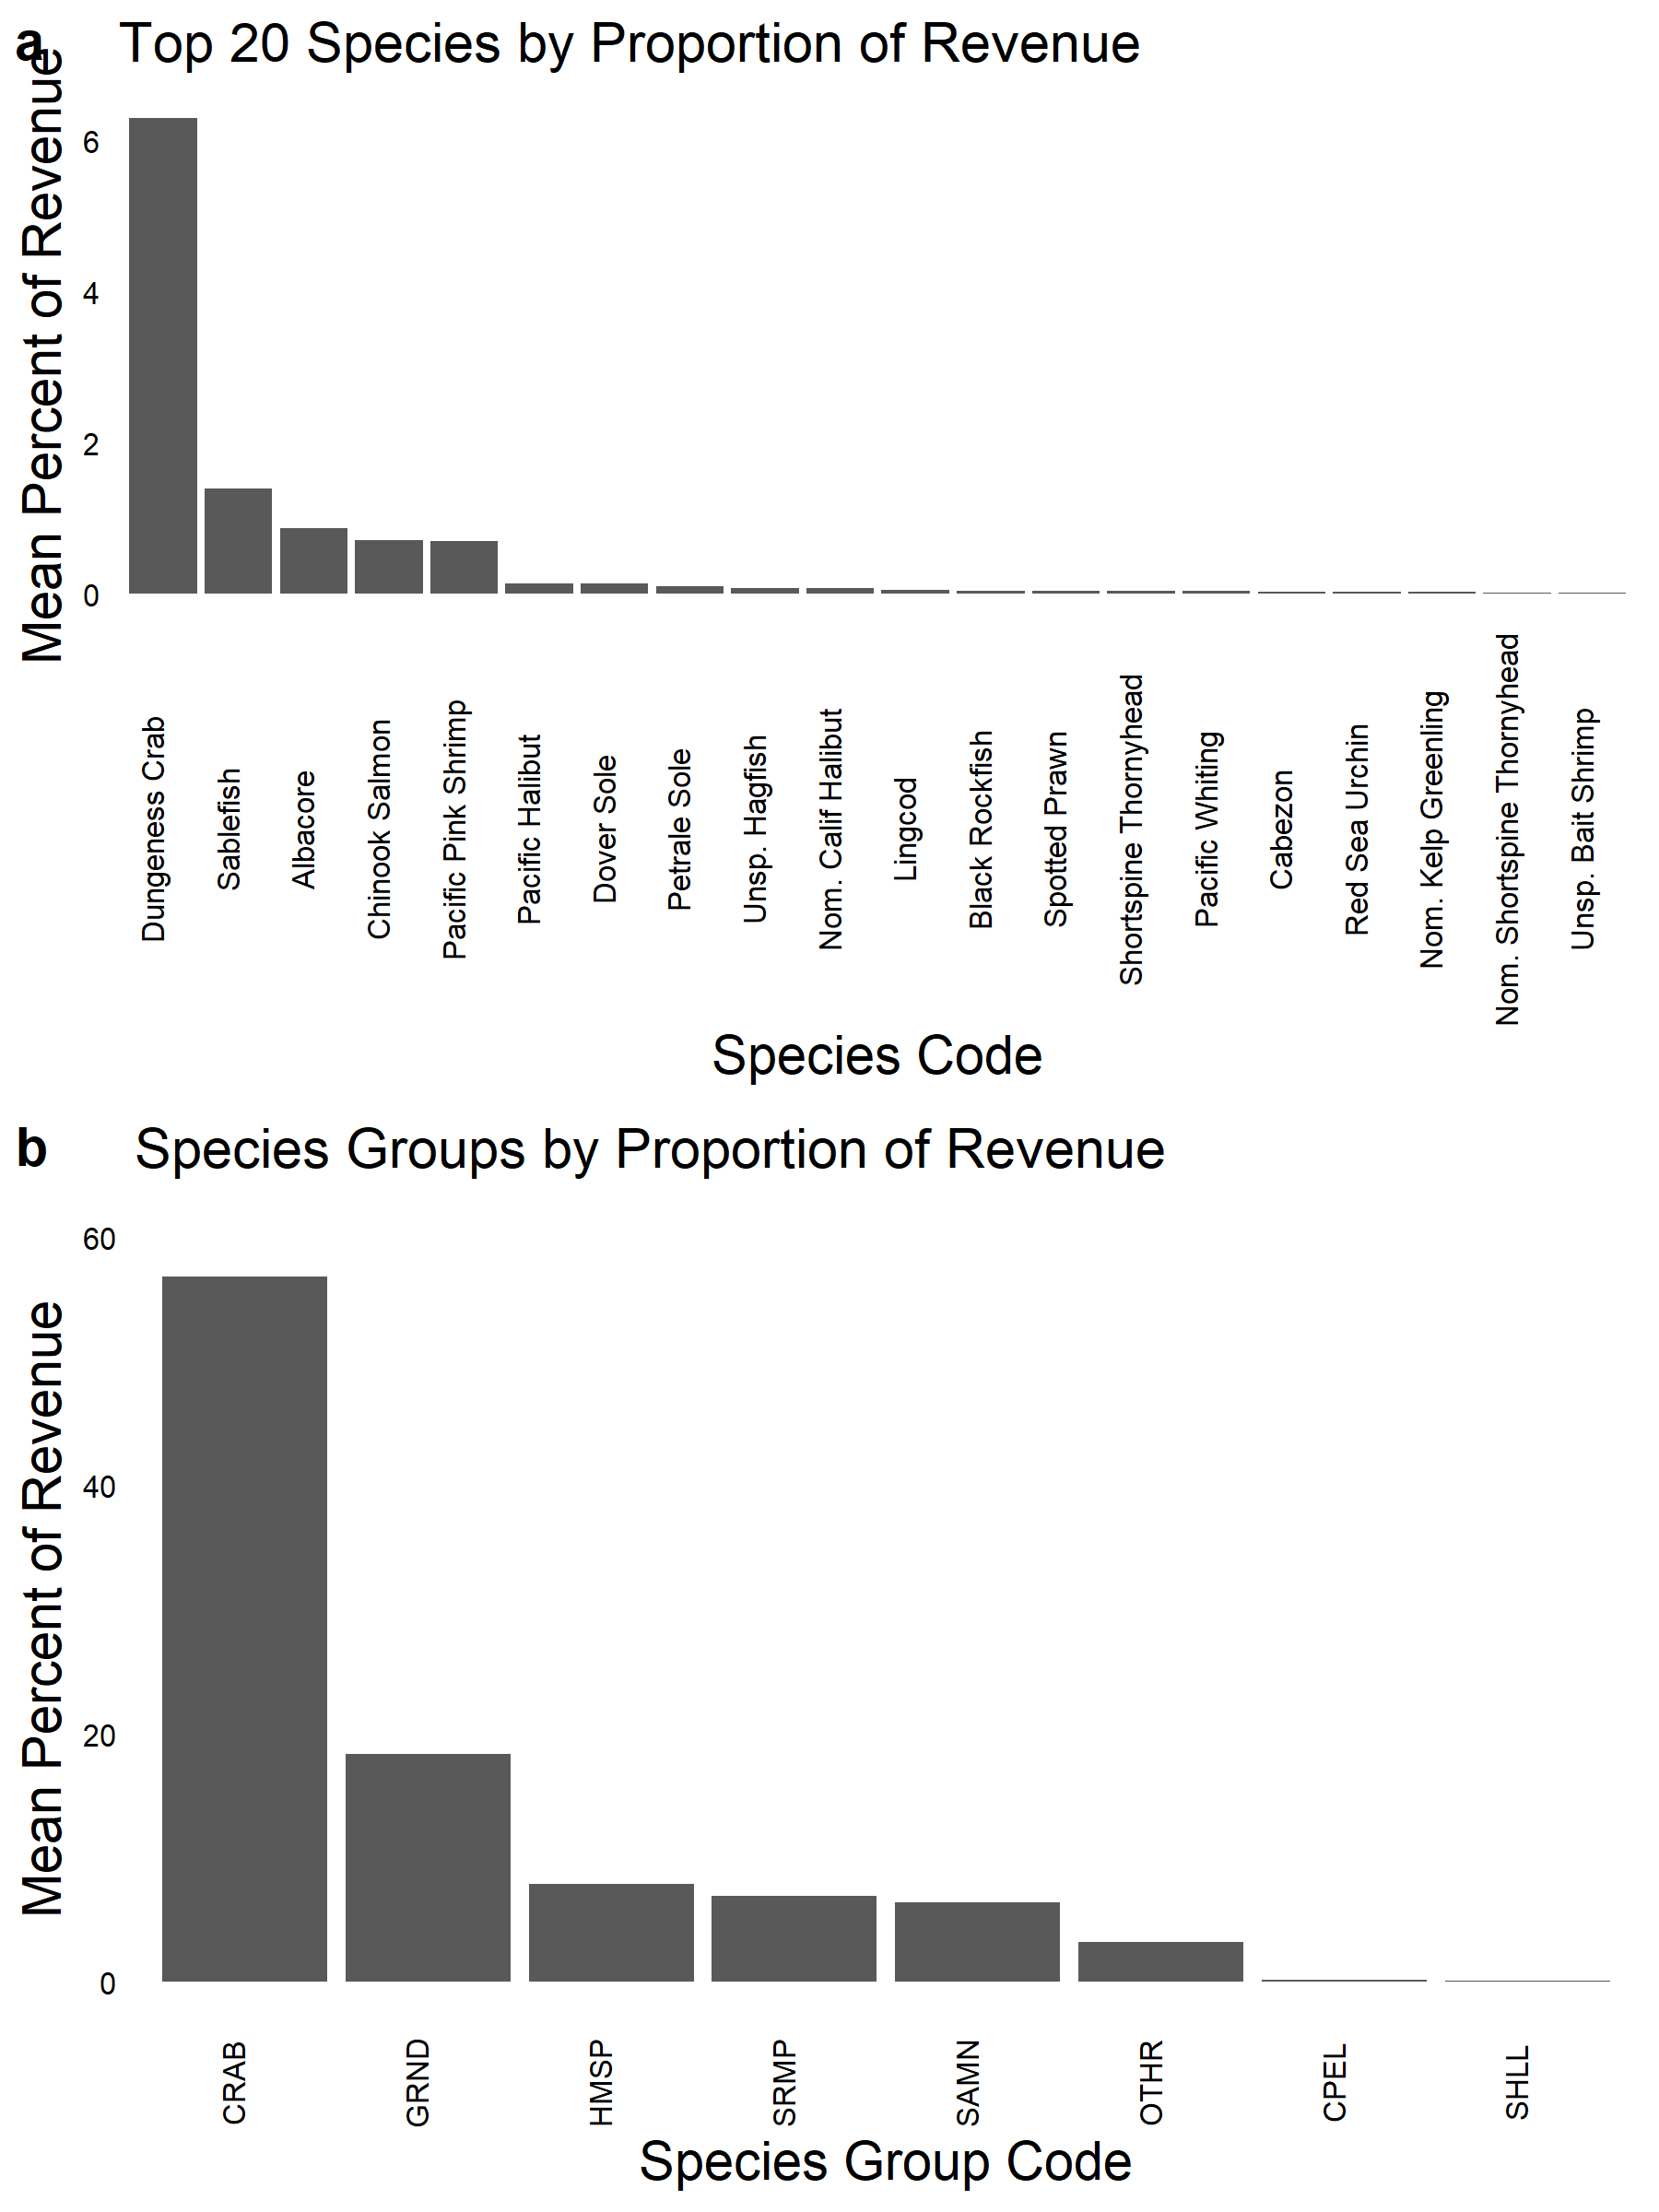

Figure A.15. Example location choice entropy time series (see equation in Construction of Fishing Behavioral Metrics in Materials and Methods). Within a vessel-season (x-axis), location choice entropy (y-axis) increases as the vessel visits novel locations, but decreases if those locations are revisited repeatedly. The metric for location choice entropy (i.e., exploration) was defined as the 90th percentile of the maximum location choice entropy observed in a vessel-season, shown here as the horizontal dashed line.

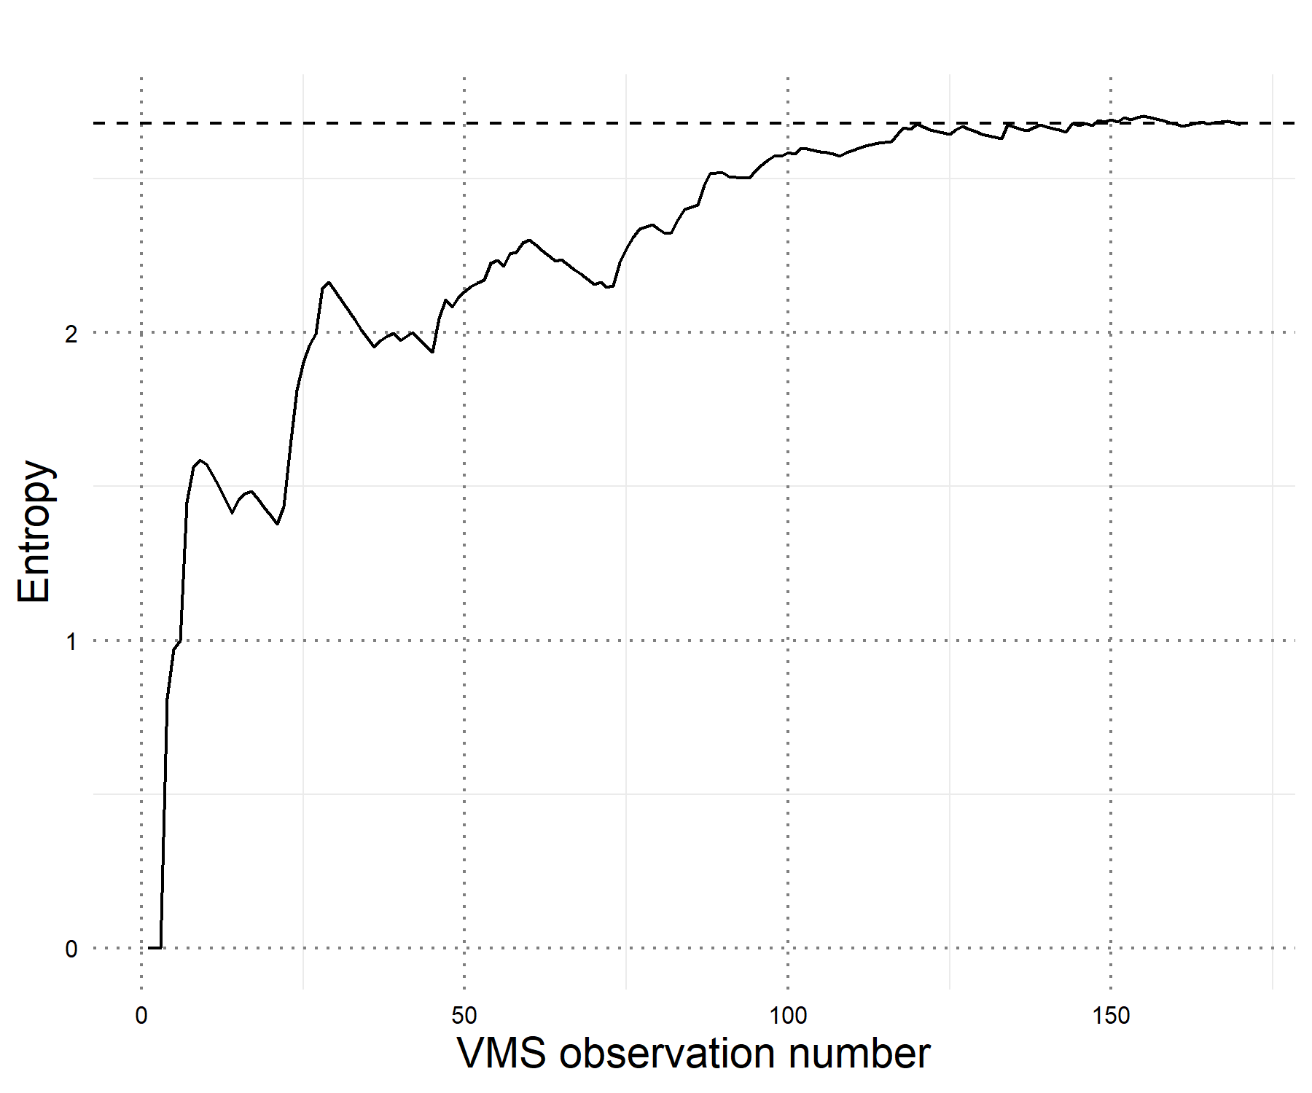

Figure A.16. Relative fuel prices used in each state, extracted from <http://www.psmfc.org/efin/data/fuel.html>. Used for calculation of fishing trip costs (see main manuscript (Materials and Methods, Dungeness Fishing Profitability).

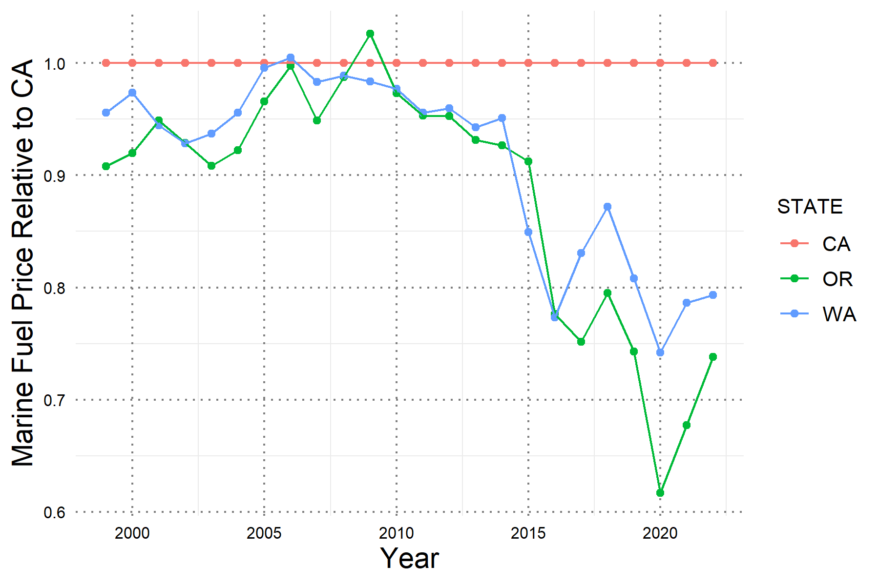

Figure A.17 Simulation of daily fishing costs in 2010 USD, by vessel length, state, and year, based on Dewees et al. (2004). See equations in main text (Materials and Methods, Dungeness Fishing Profitability). Daily fishing cost varies slightly by state as a result of different fuel prices (Fig. A.16).

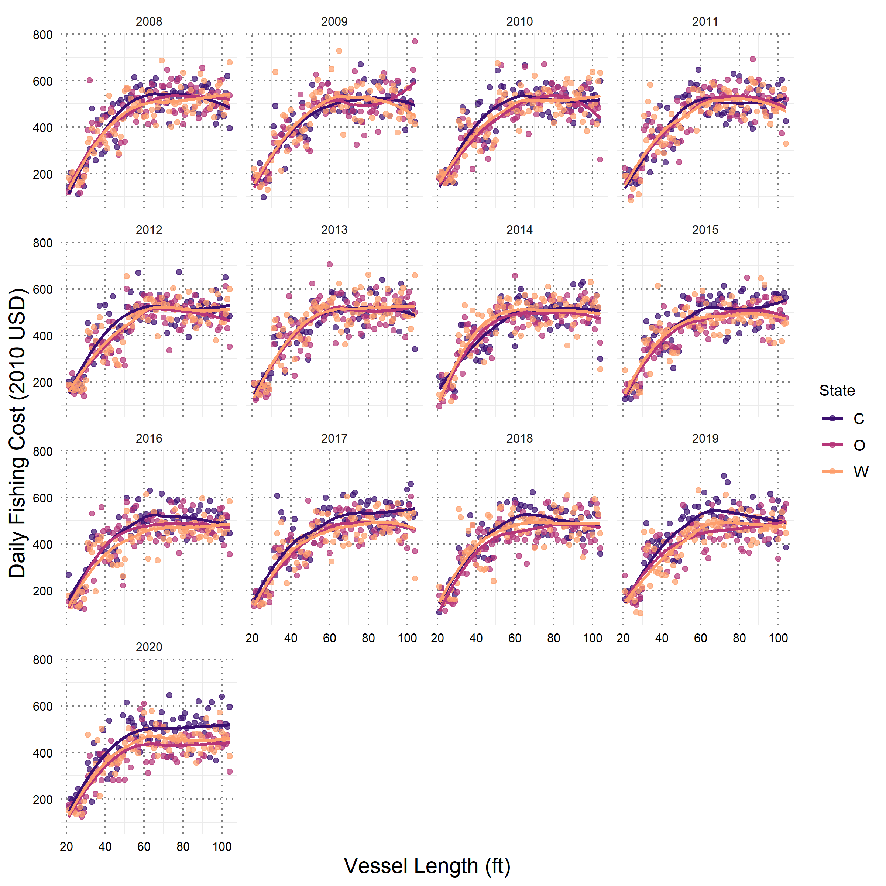

Figure A.18 Simulation of crew share as a proportion of trip revenue, based on Dewees et al. (2004). See equations in main text (Materials and Methods, Dungeness Fishing Profitability).

